Once you are done with your data science steps, finally created your model, then there is a requirement of model deployment.

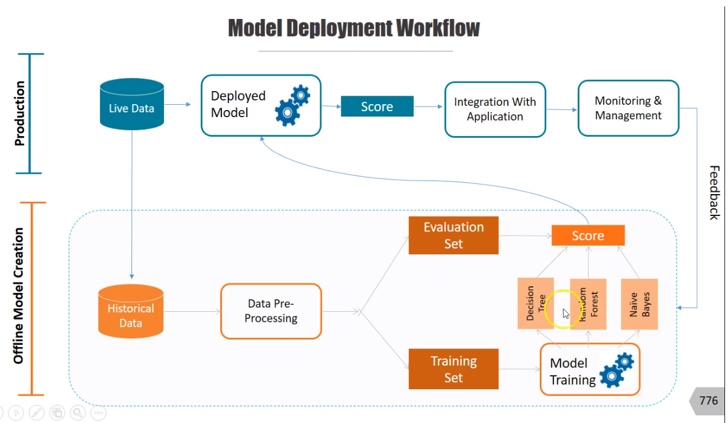

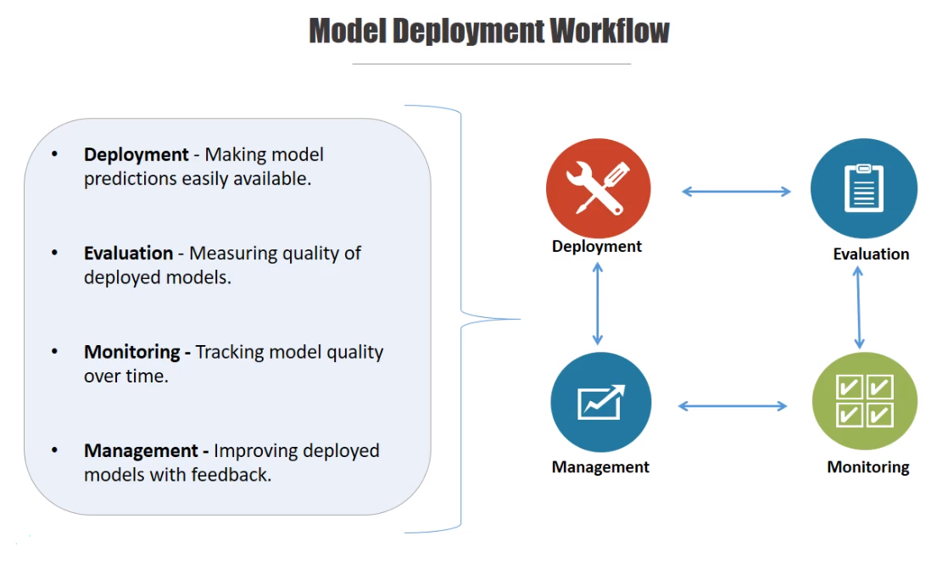

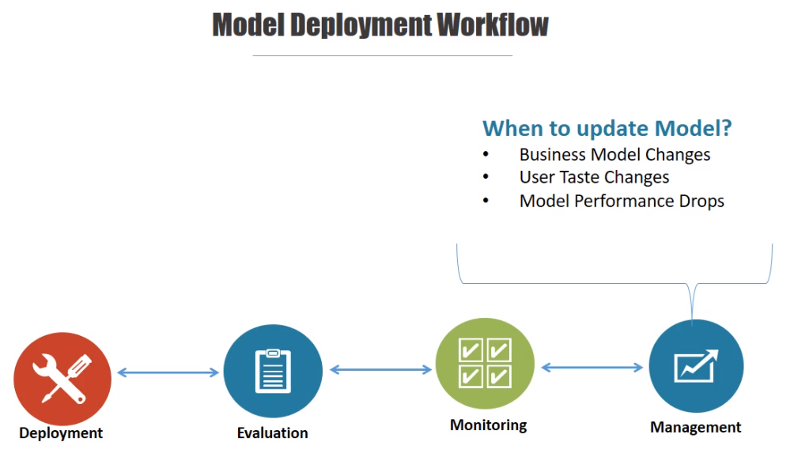

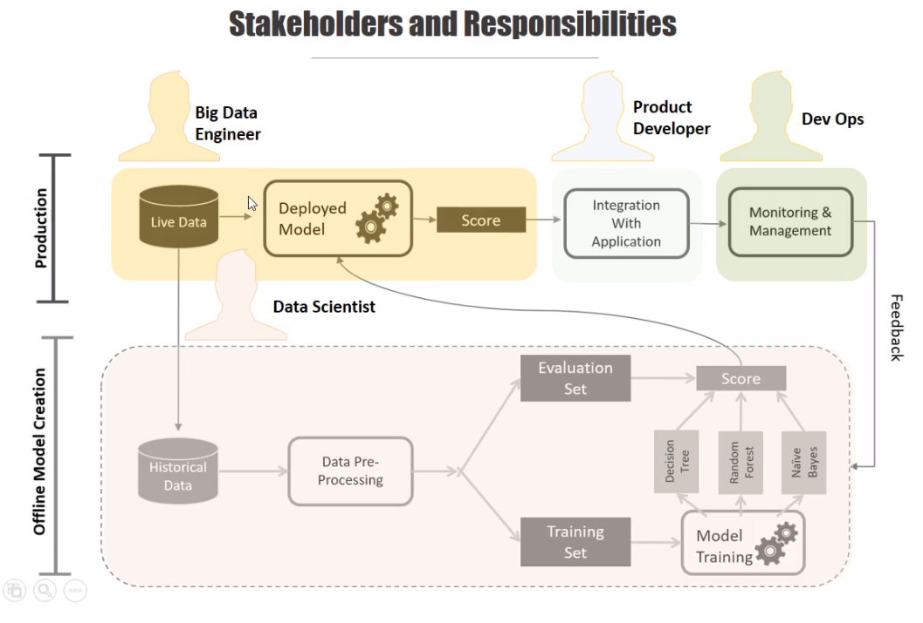

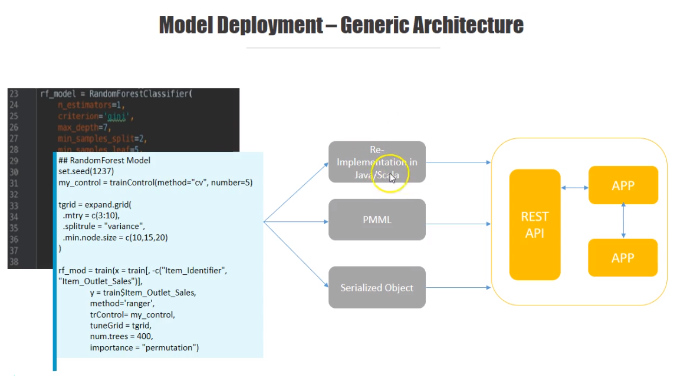

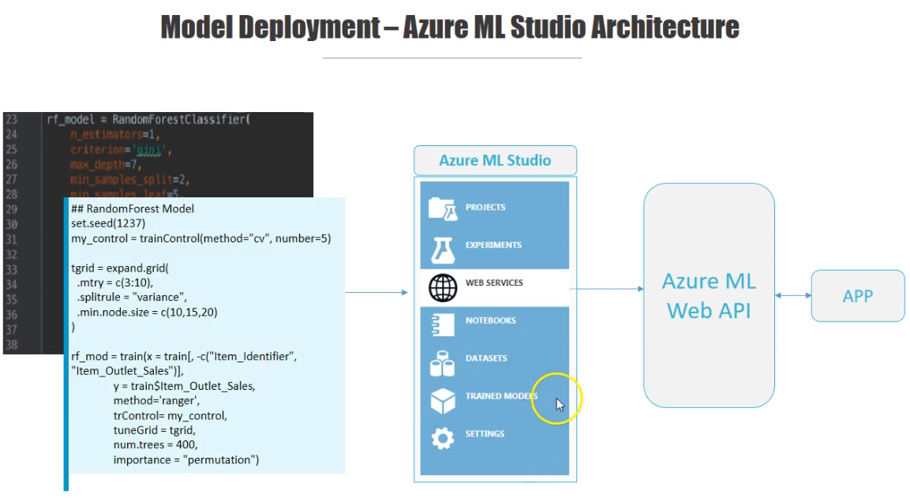

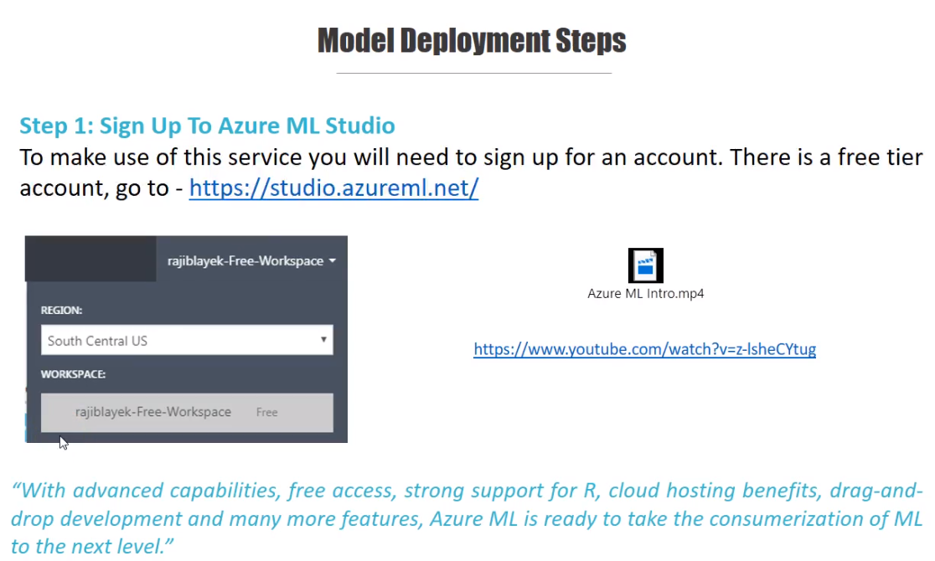

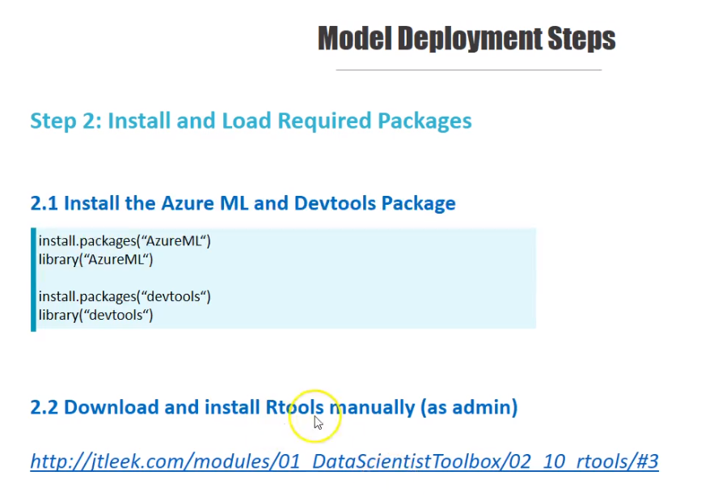

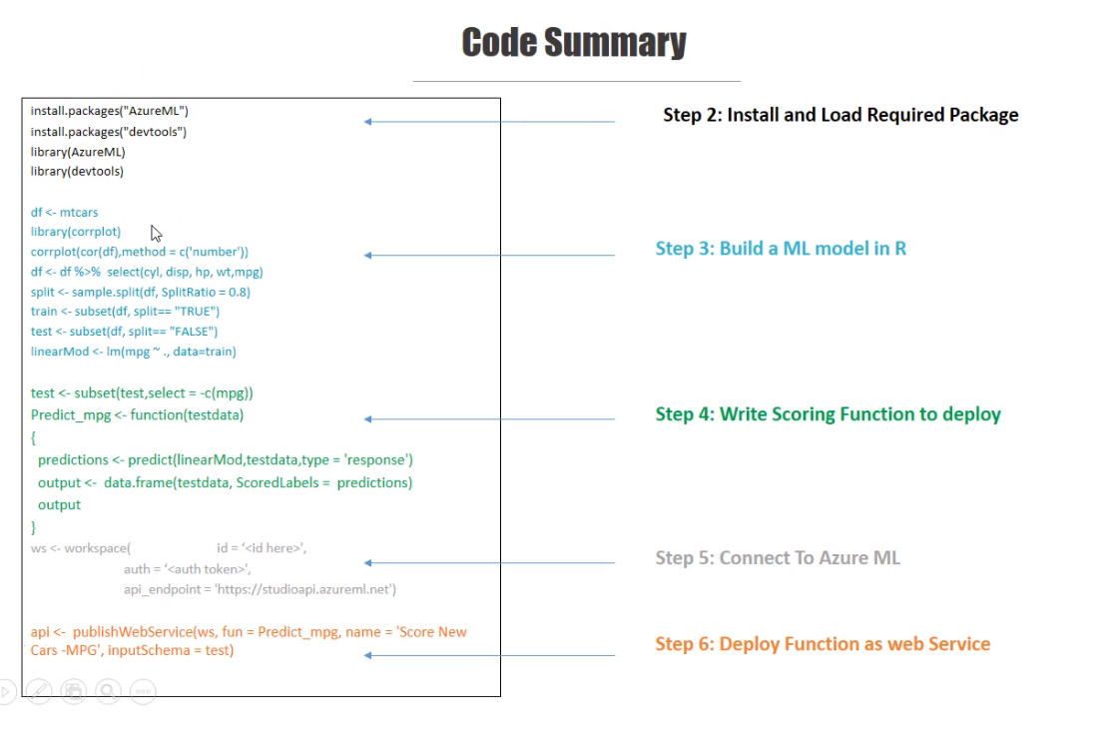

<https://medium.com/microsoftazure/how-to-deploy-externally-generated-r-models-to-azure-machine-learning-studio-web-services-41a1a5ba9df>

<https://github.com/MicrosoftDocs/azure-docs/blob/master/articles/machine-learning/studio/consume-web-services.md>

Other options:-

